**RP/ IPRC TUMBA**

**ACADEMIC YEAR: 2019-2020**

**Dept: RE**

**LEVEL 3/ SEMESTER 2**

**MODULE TITLE: AUTOMATION AND CONTROL SYSTEM**

**MODULE CODE: REN302**

**Monday 18th May, 2020**

**ASSIGNMENT 4 /**

1. What is the difference between Sensors and actuators? Give an example of four sensors and four actuators? **/6marks**

Answer1:

1. Draw a simple hydraulic system that will advance and retract a cylinder controlled by a solenoid valve using a PLC outputs. A solenoid is an actuator component that operates by converting the electrical energy into some form of mechanical motion. Sketches should include details from the PLC output card to the hydraulic cylinder**. /8marks**

Answer2: 8 marks

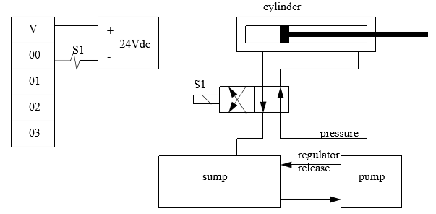

1. Draw a ladder diagram of such PLC system stated above to advance the cylinder during of 10 seconds and retract it during of 5 seconds and then restart the process again. **6marks**

Answer2: 6marks

**NB.** To be submitted not later than: **July 23, 2020** before 11:59 PM

* Submission must go through : **RP-elearning platform**
* Copy and paste will not be tolerated
* If you need further clarifications please reach me to my email or Whatsap through: **jniyitegeka@iprctumba.rp.ac.rw /+250788973044**

**Stay safe and protected by washing your hands every time, avoiding shaking your friends or any physical contact!!!!**